Reviews:
Truth Coffee:
Pic 1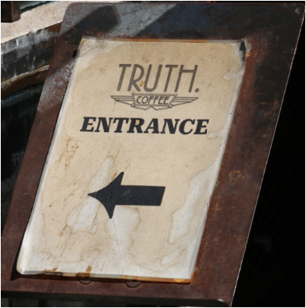
High quality coffee, unique steampunk atmosphere, and distinctive menu offering. Overall, it remains a highly recommended destination for both locals and visitors seeking a premium coffee experience in Cape Town.
Pic 2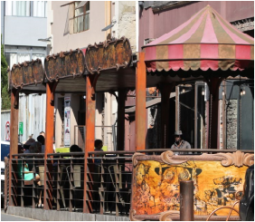
I recently stopped by Truth Coffee, and I was truly impressed! The vibe is so unique—it's a perfect mix of industrial and contemporary, with a really cool atmosphere that feels both inviting and edgy. The staff were incredibly welcoming and really knew their stuff when it came to coffee.
Pic 3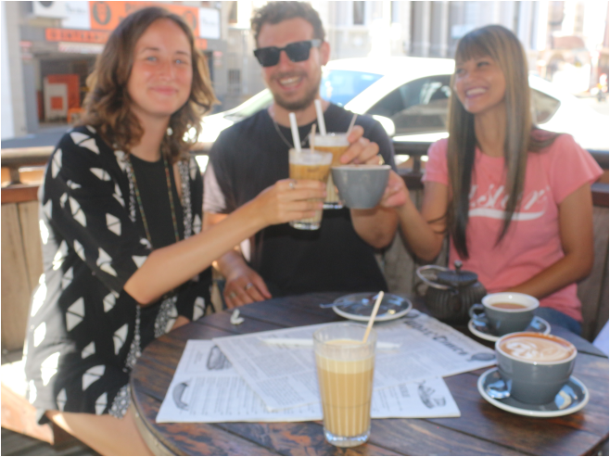
Now, the coffee itself is outstanding. I tried their signature "Truth Espresso," and it was fantastic—smooth, bold, and perfectly balanced with a touch of sweetness. You can definitely tell they take great care in selecting and roasting their beans. The pastries were a great bonus, too—fresh and delicious, especially the croissant, which went perfectly with the espresso.
If you're a coffee lover, Truth Coffee is a must-visit. I’ll definitely be coming back for more!
???????????????????????????????????????????????????????????????????????????????
Chapmans Peak Dr
Pic 1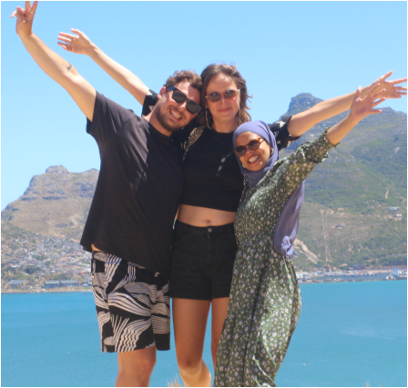
Chapman's Peak Drive is an absolute must-see! I recently had the chance to experience this iconic route, and it completely blew me away. The views are simply breathtaking, with towering cliffs on one side and the vast ocean stretching out on the other. Every twist and turn reveals a new, stunning panorama that feels like it’s straight out of a movie.
Pic 2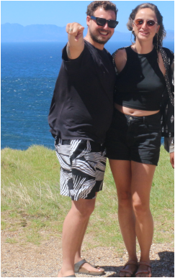
The Chapman’s Peak road itself is in great condition, and there are plenty of scenic viewpoints where you can pull over, snap some photos, or just take in the beauty. It’s the perfect spot for a relaxing drive, whether you’re looking to enjoy the landscape, catch a sunset, or simply escape for a while.
Pic 2 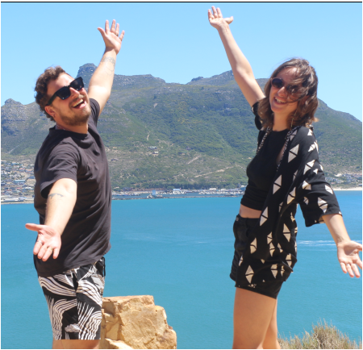
What really stands out is how the drive blends excitement with tranquility. The winding road offers a thrilling experience, but it's also incredibly peaceful. If you're in Cape Town or nearby, you definitely have to check this drive out — it’s one of those unforgettable experiences!

Sea Point
Pic 1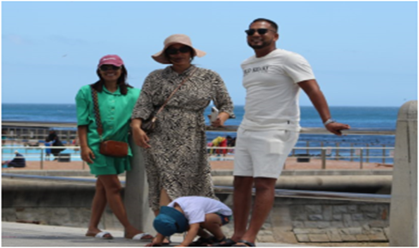
Atmosphere and Charm
Sea Point blends urban vibrancy with relaxed coastal living. Nestled along the Atlantic Seaboard, with views of Signal Hill and the ocean, it offers both scenic beauty and convenience. The community is eclectic, welcoming families, professionals, retirees, and visitors.
Its quite a long stretch of paved pathway which is really cool for jogging, walking dogs, or enjoying casual coffee spots alongside the locals.
Thanks to Nadeem for taking us around to explore the breathtaking scenic views. You are such a people’s person and made us comfortable from the very start of the trip to the drop off.
We are already preparing our next trip with Cape Frontier Travel & Tours

Pic 2 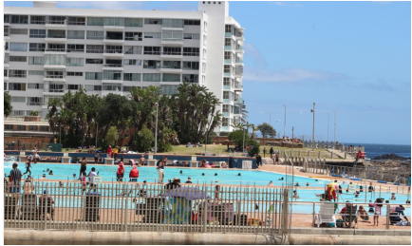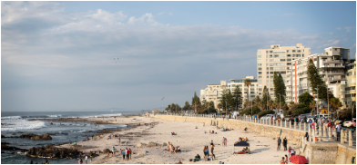
Beaches and Outdoor Fun
Firstly, I want to thank the driver of Cape Frontier Travel & Tours -If anyone out there should get a shout out, then it’s him. Patient, fun and such a gentleman-He’s time management was on point.
The area features a range of beach experiences which me and a few friends really enjoyed. If you prefer the waves to the tidal pools, it’s as refreshing by only bathing in the sun with your book and umbrella.
Pic 3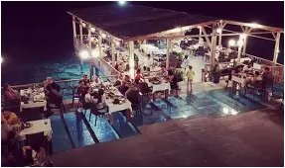
Dining and Nightlife
A fantastic and delectable food experience. Sea Point’s food scene is diverse yet unpretentious. From casual cafés and sushi spots to Italian restaurants like La Perla and local favorites such as The 41, there’s something for everyone. A range of bars and cozy lounges offer sunset cocktails or nighttime relaxation. Specialty bakeries and local food markets add unique character to the area.
Camps Bay
Pic 1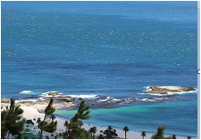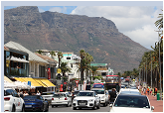
If you're visiting Cape Town, you can’t miss Camps Bay—it’s one of the most beautiful and trendy spots in the city. Situated between the stunning Twelve Apostles mountain range and the sparkling Atlantic Ocean, this area is the perfect mix of natural beauty and chic urban flair.
As soon as you step into Camps Bay, you’re greeted with one of the most picturesque beaches you’ll ever see. Think soft, white sand, crystal-clear waters, and towering mountains as the backdrop. The vibe here is a great balance between relaxed beach days and stylish, bustling streets lined with upscale restaurants and lively bars. It’s got that cosmopolitan feel, but it never loses its easygoing charm.

CBD Company Gardens
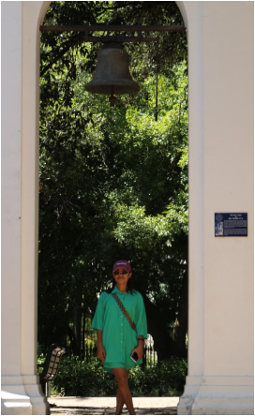
Our driver which was also our tour guide was very friendly. He kept us informed all the time and displayed good understanding of the Cape Gardens and the inner city.
If you’re a nature lover or someone who enjoys exploring beautiful, tranquil spaces, The Cape Gardens is a hidden gem you won’t want to miss. Located just a short distance from Cape Town, this botanical paradise offers a serene escape into nature, showcasing the diverse plant life that’s unique to the region.

